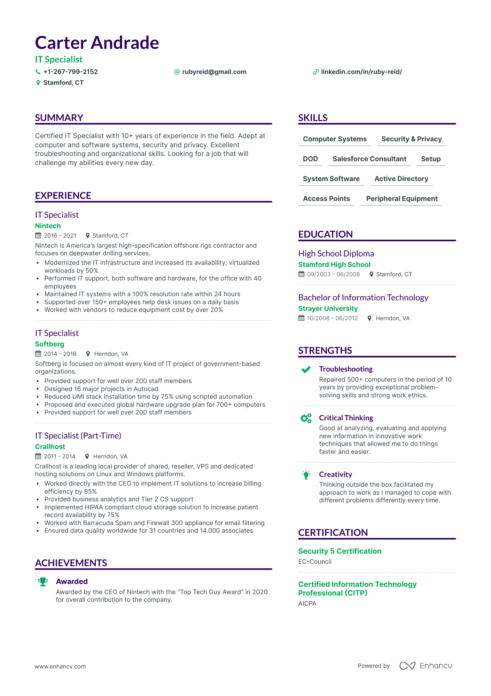
Carter Andrade
IT Specialist
+1-267-799-2152
Stamford, CT
@rubyreid@gmail.com
✔linkedin.com/in/ruby-reid/
SUMMARY
Certified IT Specialist with 10+ years of experience in the field. Adept at computer and software systems, security and privacy. Excellent troubleshooting and organizational skills. Looking for a job that will challenge my abilities every new day.
SKILLS
Computer Systems Security & Privacy
DOD
Salesforce Consultant
Setup
System Software
Active Directory
Access Points
Peripheral Equipment
EXPERIENCE
IT Specialist
Nintech
2016-2021
♥ Stamford, CT
Nintech is America's largest high-specification offshore rigs contractor and focuses on deepwater drilling services.
•
Modernized the IT infrastructure and increased its availability; virtualized workloads by 50%
Performed IT support, both software and hardware, for the office with 40 employees
Maintained IT systems with a 100% resolution rate within 24 hours
•
•
Supported over 150+ employees help desk issues on a daily basis Worked with vendors to reduce equipment cost by over 20%
EDUCATION
High School Diploma Stamford High School 09/2003-06/2008
Stamford, CT
Bachelor of Information Technology
Strayer University
10/2008-06/2012
Herndon, VA
IT Specialist
Softberg
2014-2016
Herndon, VA
Softberg is focused on almost every kind of IT project of government-based organizations.
•
Provided support for well over 200 staff members
•
Designed 16 major projects in Autocad
·
Reduced UMI stack installation time by 75% using scripted automation
Provided support for well over 200 staff members
• Proposed and executed global hardware upgrade plan for 700+ computers
•
IT Specialist (Part-Time)
Crallhost
2011-2014
Herndon, VA
STRENGTHS
Troubleshooting
Repaired 500+ computers in the period of 10 years by providing exceptional problem- solving skills and strong work ethics.
Critical Thinking
Good at analyzing, evaluating and applying new information in innovative work techniques that allowed me to do things faster and easier.
Crallhost is a leading local provider of shared, reseller, VPS and dedicated
hosting solutions on Linux and Windows platforms.
•
•
Worked directly with the CEO to implement IT solutions to increase billing efficiency by 85%
Provided business analytics and Tier 2 CS support
• Implemented HIPAA compliant cloud storage solution to increase patient record availability by 75%
• Worked with Barracuda Spam and Firewall 300 appliance for email filtering
•
Ensured data quality worldwide for 31 countries and 14.000 associates
Creativity
Thinking outside the box facilitated my approach to work as I managed to cope with different problems differently every time.
ACHIEVEMENTS
CERTIFICATION
Security 5 Certification
EC-Council
Awarded
Awarded by the CEO of Nintech with the "Top Tech Guy Award" in 2020 for overall contribution to the company.
Certified Information Technology Professional (CITP)
AICPA
www.enhancv.com
Powered by
Enhancu

